Gold Price Linear Model

College of Staten Island City University of New York

Weicong Feng

November 2019

# Intro

Gold is not general precious metal, but also potential currency, important industrial raw material, adornment and financial tools. Whether for investors or financial policy makers, or related industrial producers, forecasting gold prices has important practical implications. People have been keen to predict gold prices just like forecasting stock market fluctuation. This paper creates a model to explain the relationship of gold price and relevant variables.

# Literature Review

In reality, economy is complex, gold prices are effected by a number of factors. Kauffmann and Winters (1989) pointed out that US dollar index has a major impact on gold price, while Barsky and Summers (1988) claimed that interest rate correlated with gold price in long term, is dominant factor. Other researches indicated monetary policy, inflation, demand and supply of gold, and politics even have different impact on change of gold price.

US Dollar Index: Kauffmann and Winters (1989) believed price of gold fluctuate inversely with the value of US dollar mainly because its price is denominated in US dollar (Said Elfakhani el., 2009). However, Soumya Sharma (2015) interpreted this relationship as the appreciation of US dollar causing gold which is denominated in US dollar to appreciate against other currencies, thereby suppress consumption of gold (Soumya Sharma, 2015).

Interest Rates: In general, interest rates are considered to be inversely related to gold price. Actually, real rate is more important than nominal rates. High interest rates drive investors to hold higher yields on risky assets because holding a non-interest precious metals means higher holding cost. During negative real interest rates periods, holding bonds leads to loss purchasing power, while gold is traditional tool for store of wealth (Soumya Sharma, 2015).

# Data

In general, gold price is mainly driven by following factors:

* Currency markets
* Interest rate/monetary policy
* Inflation
* Geopolitics
* Equity markets
* Demand

Currency markets is an important factor for gold price, especial in US dollar price, because gold price is usually denominated in US dollars. The federal interest rate and 10 years yield could be used to measure interest rate and inflation. During attempt of involving geopolitics, it was found that wars and conflicts happened almost every year, some wars even continued from 15 years ago. Simple dummy variable cannot explain the impact of geopolitics on gold price. Hence, geopolitics factor is ignored. In the first year or two years of the crisis, especially the big economic crisis, the stock market will have a clear opposite direction with gold price. After that, the stock began to recover, and gold is still a risk hedging tool that investors hold in large numbers, and they are starting to run in the same direction. Therefore, the direction of stock volatility and gold price are not clear. On the other hand, Historical supply and demand data of gold only found the last 10 years and had to give up.

US dollar index, federal interest rate and 10 years yield historical data were download from finance yahoo, while gold price historical data was download from GOLDHUB([www.gold.org](http://www.gold.org)) for the period of December 31, 1970 to May 31, 2019. Theoretical, the monthly change in gold price can be predicted based on the percentage change of US dollar index, federal interest rate and 10 years yield. There are total 582 observation.

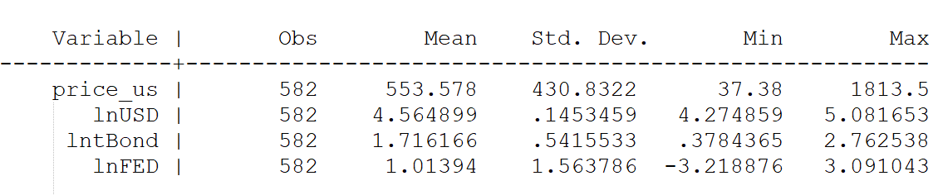

US Dollar Index is a factor which has a great impact on gold price. Because gold is generally denominated in US dollars, so gold price is inversely related to the US dollar, as shown in Figure 2 below. In this sample, the monthly average percentage change of US Dollar Index runs around 4.5649, and has a lower variance. On the other hand, gold price is very sensitive to interest rates. When the economy is in recession, interest rates and most of the investment returns are declining and unattractive, and investors will buy more gold as an anti-risk asset. Federal fund rate and 10 years bond yield rate can be considered as short-term and long-term interest rate indicators, respectively. As theory, figure 3 and figure 4 show that the monthly percentage change of them and gold price are opposite correlation.

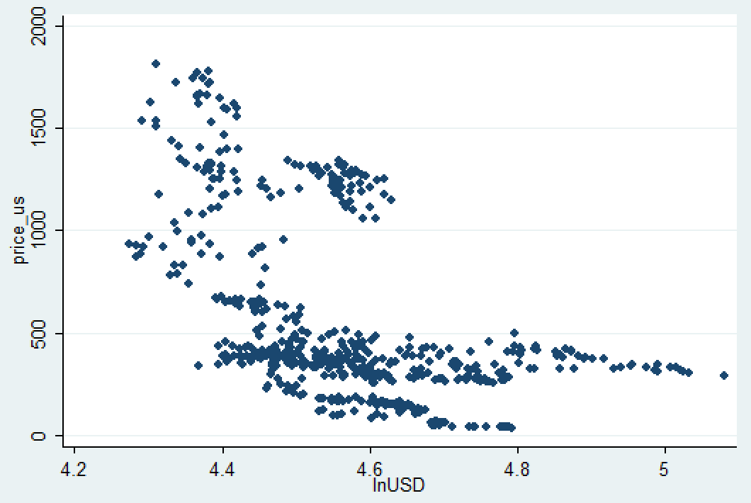

Figure 2

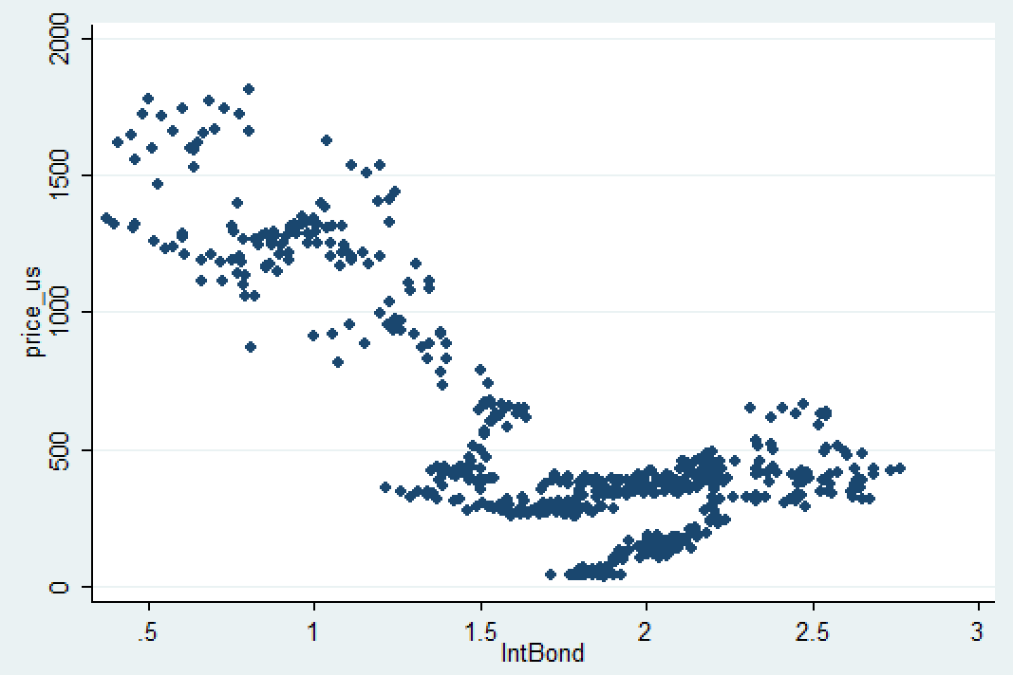

Figure 3

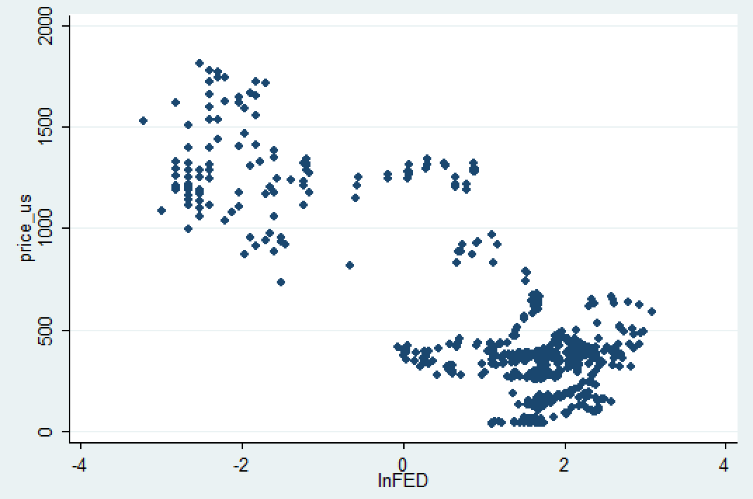

Figure 4

# Methodology

The OLS model for predicting gold price is supposed to be:

* - -

price_us = β0 + β1*lnUSD + β2*lntBond + β3*lnFED + ε

The hypotheses should be:

* ***lnUSD (independent),*** the monthly percentage change of US dollar index, which represents US dollar going up or down. It is expected to have a negative coefficient because gold price and US dollar are negative relationship. Gold is usually denominated in US dollar. The nominal price of gold will decline when the price of US dollar increases, holding other conditions constant.
* ***lntBond (independent),*** the monthly percentage change of 10 years bond yield, an indicator of long-term interest rate. It should have a negative coefficient because gold price and US dollar are negative relationship. The 10 years bond yield will go down while the economy is expected to be depressed in the future, conservative investor will improve their countercyclical asset, including gold. So, gold price goes up as the monthly percentage change of 10 years bond yield going down.
* ***lnFED (independent),*** the monthly percentage change of federal fund rate, an indicator of short-term interest rate. Similar to 10 years bond yield, federal fund rate will fall when the economy is down. The difference is that it is more responsive to current short-term economic changes. Hence, it ought to have a negative coefficient.
* ***price_us (dependent),*** the gold price, predicted variable. In the case of missing demand and supply variable and geopolitics variable, this model inevitably violates Class Assumption III. Nevertheless, the above three independent variables have a major impact on the gold price, the model can basically explain the gold price.

# Results

The model was estimated in STATA, and the regression output is shown below:

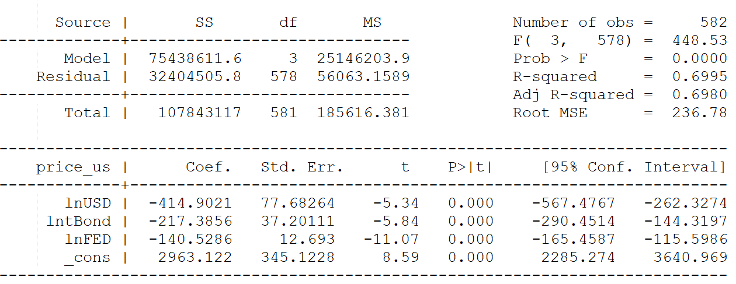

So, the estimate should be:

price_us = 2963.12 – 414.90*%ΔUSD – 217.38*%ΔtBond – 140.52*%ΔFED

Suppose US dollar index, 10 years bond yield and federal fund rate respectively increase 1%, gold price is expected to decrease 772.8 (– 414.90 – 217.38 – 140.52) in value.

The estimate of the percent change in US dollar index is negative, is consistent with previous supposition. The 95% confidence interval from -567.47 to -262.32 suggest that the US dollar index is statistically significant.

The estimate of the percent change in 10 years bond yield is -217.38, with P>| t | of 0.000, which can be believed that 10 years bond yield is reliable predictor of gold price.

Similarly, the estimate of the percent change in federal fund rate is -140.52, as previous assumption. The high absolute t value of -11.07 point out that federal fund rate is reliable and important variable for regression of gold price.

The R2 of 0.69 and adjusted R2 of 0.69 indicate that this OLS model has relative strong predictive power, that near 70% gold price change can be explained by this model.

# Conclusion

According to the result of model regression, it can be known that the gold prices are strong negative relationship with the percentage change of US dollar index, 10 years yield and federal fund rate. Among these three factors, US dollar fluctuation has the most important affect on gold price change. On the other hand, either t value or p value indicates that all of these three independent variables are statistical significant on gold price.

# References

Elfakhani, Said & Baalbaki, Imad & Rizk, Hind. “Gold price determinants: empirical analysis and implications.” (2009)

Mamcarz, Katarzyna. “Determinants of Gold Price in the Short Term.” (2015).